*Florida International University*

*School of Computing and Information Sciences*

Software Engineering Focus

Final Deliverable

Project Title:   
Keeping Mothers and Infants Healthy

**Team Members:** Michael Llanes, Noe Velasquez, Gabriel Alfonso, Amin Sheikhnia

**Product Owner(s)**: Jean Hannan

**Instructor**: Masoud Sadjadi

The MIT License (MIT)

Copyright (c) *2016 Florida International University*

Permission is hereby granted, free of charge, to any person obtaining a copy of this software and associated documentation files (the "Software"), to deal in the Software without restriction, including without limitation the rights to use, copy, modify, merge, publish, distribute, sublicense, and/or sell copies of the Software, and to permit persons to whom the Software is furnished to do so, subject to the following conditions:

The above copyright notice and this permission notice shall be included in all copies or substantial portions of the Software.

THE SOFTWARE IS PROVIDED "AS IS", WITHOUT WARRANTY OF ANY KIND, EXPRESS OR IMPLIED, INCLUDING BUT NOT LIMITED TO THE WARRANTIES OF MERCHANTABILITY, FITNESS FOR A PARTICULAR PURPOSE AND NONINFRINGEMENT. IN NO EVENT SHALL THE AUTHORS OR COPYRIGHT HOLDERS BE LIABLE FOR ANY CLAIM, DAMAGES OR OTHER LIABILITY, WHETHER IN AN ACTION OF CONTRACT, TORT OR OTHERWISE, ARISING FROM, OUT OF OR IN CONNECTION WITH THE SOFTWARE OR THE USE OR OTHER DEALINGS IN THE SOFTWARE.

***Abstract***

The purpose of this document is to provide the reader with precise information regarding the new developments to the Keeping Moms and Infants Healthy application brought upon by the computer science school’s Summer 2020 Senior Project team. Offered are the exact technologies, methodologies, and logistics behind the improvements to the application.

This application functions as an information hub for low-income mothers with newly born, or soon-to-be newly born, infants regarding the prenatal, postnatal, and continued care of the infant and mother. Clinic and shelter availability as well as filtering capabilities in their search, ability to alter personal information within the app, health tips for illnesses and infant care via information dashboards or weekly notifications according to infant-age milestones, and information accessibility through access to documents uploading pages, appointment and reference information logging pages are the many features that have been embedded into the application for the purpose of easing the lives of low-income mothers and their infants. Such services and information require great effort to access in the uncentralized arena that is the general internet, prompting the team to push for fleshed out and familiar features that anyone can learn to use intuitively for the purpose of providing access to the services and information at hand.

**Table of Contents**

**Introduction** …………………………………………………………………………………………….....5

Current System ……….…………………………………………………………………………………………………..6

Purpose of New System …………………………………………………..………………………….....6

**User Stories**

Implemented User Stories ………………………………………….…………………………………...7

Pending User Stories …………………………………………………………………...………………………………..……10

**Project Plan**

Hardware and Software Resources ……………………………………………………………….…...11

Sprints Plan ……………………………………………………………..…………………………………………...12

*Sprint 1*  ……………………………………………………………………………………………………….12

*Sprint 2*  ……………………………………………………………………………………………………… 13

*Sprint 3*  ……………………………………………………………………………………………………… 14

*Sprint 4*  ……………………………………………………………………………………………………… 14

*Sprint 5*  ………………………………………………………………………………………………………16

*Sprint 6*  ………………………………………………………………………………………………………17

**System Design**

Architectural Patterns ………………………………………………………………………………………………………….19

System and Subsystem Decomposition …………………………………………………………………………….……………………………20

Deployment Diagram …………………………………………………………………………………………………….…....20

Design Patterns ………………………………………………………………………………………………………….21

**System Validation**  ……………………………………………………………………………………………………………..21

**Glossary**  ……………………………………………………………………………………………………………..27

**Appendix**  ……………………………………………………………………………………………………………..28

Appendix A - UML Diagrams ………………………………………………………………………………………………………….28

Appendix B - User Interface Design …………………………………………………………………………….…........................................42

Appendix C - Sprint Review Reports …………………………………………………………………………...……………………………..43

Appendix D - User Manuals, Installation/Maintenance Document, Shortcomings/Wishlist Document and other documents  
…………………………………………………………………….…………………………………....53

**References** ……………………………………………………………………………………………………………57

**Introduction**

Keeping Moms and Infants Healthy is a unique application that is designed to help low-income mothers to keep their infants healthy. This application provides the necessary information about prenatal care, postnatal care, health services, advice for babies and mothers on the pregnancy process, health issues, access to clinics, shelters, and other resources. Furthermore, the application is designed to support three languages: Spanish, Creole, and English.

Due to the application being designed to help a low-income mother and their infant’s healthcare, it provides services such as information for shelters around the Miami area, contact information for each shelter and clinic, Google-Map accessibility for navigation, as well as filtering options for all clinics available. In this new version, the app also allows the user to schedule appointments for any medical purpose. Plus, each appointment will be synchronized to the default calendar on their phone. Besides the appointments feature, we implemented a reference feature that allows users to note references for medical professionals to have access to health services through call or email.

Furthermore, the application is designed to allow users to upload cloud-stored documents that are relevant to healthcare and financial care. This will give the user the ability to have all the documents stored in a single app. Another feature that was added was the settings page which allows the user to update and make changes to their personal information in the app. The app now offers relevant information on how to take care of infants and have a better understanding of what to do in the stages of the pregnancy, by implementing weekly notifications via text messages that help mothers take the necessary steps and tools into account. Other such medical information now available in the application are protected-sex guides, STD awareness for a range of illnesses, and links to applications for Medicaid and WIC

## 

## 

## 

## 

## 

## **Current System**

The previous version of the Keeping Moms and Infants Healthy app was very limited and did not provide the functionality behind many features to users. Only the basic UI and back-end for the application were built by the previous team. There was no information available regarding shelters, clinics, the ‘Learn’ tab, and the ‘Resources’ tab. There were no filtering options in the clinics searching feature as well as a lack of distance sorting for the list of clinics. The user did not have the option to update or make changes to their personal information. Not to mention the application failed to offer other features such as scheduled appointments, noting references for medical professionals, and uploading documents. In addition, the app did not provide information such as protected-sex guides, STD awareness, linking to applications for Medicaid and WIC, and other relevant information about health care. The current system of the application was built on relatively inefficient code that relied on class inheritances and props passing throughout.

**Purpose of New System**

The purpose of this new version is to embed the functionality of features that the application is meant to service. The features added to the application were developed in a robust fashion that account for multiple use cases and an intuitive flow for the user. The code was restructured to ease a future developer’s workflow and improve performance throughout the application.

This new version has the following features:

• Forgot password features.

• Support in English, Spanish, Creole.

• New Shelter locations.

• Filtering options by distance and services for Clinics.

• New Learn section for STD awareness and protected sex information.

• New Settings feature to update and change user information.

• New Resources feature that provides information to apply to WIC & Medicaid.

• New documents feature to view and upload documents.

• New appointments feature to schedule your medical appointment.

• New reference feature to reference medical professionals.

• Alerts for appointments and notifications for newborn babies.

• Advisory weekly SMS messages for infants and pregnancy.

**User Stories**

**Implemented User Stories**

|  |  |  |
| --- | --- | --- |
| **ID** | **Belongs to** | **Implemented User Stories** |
| **1** | Everyone | As a developer I would like to familiarize myself with the current status of the app and the documentation left behind by the previous developers, so I better improve upon the application. |
| **2-5** | Everyone | As a developer, I want to setup my development environment and learn the fundamentals of the technology stack we will use so that I can develop the required features |
| 6 | Gabriel | As an Android user I would like to have the application available to Android phones, so I can also use the app |
| 7 | Gabriel | As a user I would like a back button on the lower panel so that I can go back to the selection |
| 8 | Gabriel | As a user I would like to focus the lower Panel by clicking its header so I can better navigate the app |
| 9 | Gabriel | As a user I would like the scroll functionality on all the lower panel sections so I can use it anywhere in the lower panel. |
| 10 | Gabriel | As a user I would like a weekly notification with tips about newborns so I can better take care of my baby |
| 11 | Amin | As a user I would like to access a learn tab which provides health information about pregnancy and birth so I can stay safe and keep my baby safe |
| 12 | Mike | As a user I would like to access a Tips & Tricks tab which provides useful information about tips and tricks of pregnancy, giving birth, child caring and sex safety so I can stay safe and healthy more productively. |
| 13 | Mike | As a user I would like to specify the age of my baby or whether they are born or not so I can better be served by the app. |
| 14 | Noe | As a user I would like to add a setting edit icon where the user can edit info, logout or app setting so I can configure my user experience. |
| 15 | Gabriel | As I user I would like to go back in between the sign up steps so I can make sure I provide accurate information |
| 16 | Mike | As a user I would like to see individual fields on entering my date of birth so that editing can be easier. |
| 17 | Mike, Gabriel | As a nuMom(user), I would like to sort clinics by proximity, so I can better choose a convenient clinic to visit. |
| 18 | Mike | As a user I would like to upload and access certain medical documents with ease so that when they are requested or I must reference them for access to child-rearing care I can. |
| 21 | Mike | As a user I would like to **FILTER** Clinics in terms of proximity (5 mile radius, 10 mile radius), so I can better choose a clinic that is right for me. |
| 22 | Gabriel | As a user I would like to **FILTER** Clinics in terms of services they provide, so I can better choose a clinic that is right for me. |
| 23 | Amin | As a user I would like to store appointments I have for my child and I so that I can easily keep track of my appointments |
| 24 | Noe | As a user I would like to set up a forgot password feature , so users can reset the password based on the email. |
| 25 | Gabriel | As a user I would like to stack the filters for clinics on top of each other to be able to filter multiple parameters at once. |
| 26 | Gabriel | As a user I would like to get SMS notifications to notify me of my appointments so that I can be notified of my upcoming appointments. |
| 27 | Gabriel | As a user I would like to have a button that when clicked resets all set filters to default, so I don’t have to manually reset them in the Clinics tab |
| 28 | Gabriel | As a developer, I would like a way to incorporate text fields for dates that are more intuitive and compatible in general, so that I can implement them in the app straightforwardly and with confidence |
| 29 | Gabriel | As a user I would like to receive in-app notifications so I can remember to use the app to its full potential |
| 31 | Amin | As a user I would like to not disclose the gender of my baby if it is unnecessary, so I can provide less information and keep more of my privacy |
| 32 | Amin | As a user I would like to add more Resources of Zika, Hepatitis information so I can inform the user with the health diseases. |
| 33 | Noe | As an old user I would like the settings page to be compatible with my account, so I don't have to re-create my account |
| 34 | Gabriel | As a dev, I would like for the Firebase API to NOT create a new instance in every component, so the app can save memory and be more efficient |
| 35 | Gabriel | As a developer I would like to transform the components to use functions and React hooks, so that the code is easier to read, to maintain, and to expand |
| 36 | Gabriel | As a user I would like the delete filter button to only show up when there are filters to delete so that it doesn't get in the way when it is not needed. |
| 37 | Noe | As a user I would like to delete appointments whenever I want, so that I can only see relevant appointments. |
| 38 | Gabriel | As a user, I would like a button to show/hide the filter selection dropdown menus, so that I have more room to look at the clinics when hidden. |
| 39 | Amin | As a user I would like to use the appointments tab efficiently and for it to look appealing to the eye so that I won't get frustrated when using the application. |
| 40 | Gabriel | As a user I would like the clinics to load from a database, so that it loads the sorted clinics faster |
| 41 | Noe | As a user I would like to edit the weekly messages json file, so that it has an efficient way to deliver messages. |
| 42 | Gabriel | As a user I would like for appointments to delete themselves the day after the appointment occurred so they don't clutter up, and I don’t have to manually remove them. |
| 43 | Gabriel | As a dev, I would like for the clinics to be stored in the database, so the App behaves more dynamically |
| 44 | Gabriel | As a user I would like the dropdown menu for the filters to look more aesthetically pleasing so my user experience is more fluid. |
| 45 | Gabriel | As a user I would like to receive a push notification when I indicate that I have a new child, so that my user engagement with the app improves. |
| 46 | Gabriel | As a user I would like a loading screen while the clinics are being fetched before the map is shown so that the map shows correct data when it does load. |
| 47 | Gabriel | As a dev I would like for a new animation for the lowerPanel moving up and down, so that the app is more fluid and efficient |
| 48 | Mike | As a user I would like to take a picture within the app and save it immediately into the app and the phone. |
| 49 | Mike | As a user I would like to have all my saved files listed within the app so that I can access them conveniently. |
| 50 | Amin | As a user I would like to learn about female condoms, so I am better informed about sexual health |
| 51 | Noe | As a user I would like to store the name of my doctors and specialists in the app, so I can look at them for reference |
| 52 | Gabriel | As a developer, I would like to have the clinic services drawn from getLocalizedText so that it can be dynamic to the language the user is using. |
| 53 | Gabriel | As a user I would like to view shelters that are useful and accessible so that I would have those options available to me. |
| 54 | Amin | As a user I would like to have all information available in any language that I may want to read in so that I can properly utilize the application. (Waiting on PO for information) |
| 55 | Mike | As a user I would like to have a link to a helpline that can provide me with further information so that I can be clear about my choices. |
| 56 | Gabriel | As a user I would like for the sign in page to not crash the app when I press the sign in button without offering any input, so that the app doesn't crash |
| 57 | Noe | As a user, I would like to sync the appointments from calendars to the app, so I don’t have to create it inside the app and have all the appointments in one place. |
| 58 | Gabriel | As a dev I would like to import GetLocalizedText instead of passing it as props, so that the app is more efficient |
| 59 | Mike | As a user I would like to have a button in the upper right corner of the documents page that prompts for adding a document instead of it being in the center. |
| 60 | Gabriel | As a developer I would like to abstract a Button component so that I can use it with all the buttons in the App instead of having several Button components, so that the code flows better |
| 61 | Noe | As a user I would like to change the New Appointment icon to a plus icon, so the app style looks decent and better. |
| 62 | Noe | As a user I would like to change the Time and date to a Picker, so we could have better efficient data. |
| 63 | Mike | As a user, I would like to be able to name the files I upload so that I can know what each document pertains to. |
| 64 | Noe | As a user I would like to change the styles for Android Picker so the app looks decent. |
| 65 | Gabriel | As a user I would like for the style of the picker for the dropdown filter to be improved so that it matches the rest of the app and improves my user experience |
| 67 | Gabriel | As a dev, I would like to keep all the components inside LowerPanel inside an object of components, so that every component can be called by its property name. |
| 68 | Amin | As a user I would like to see the STD names so that I can choose the STD I want to look at. |
| 69 | Gabriel | As a user I would like for the lowerPanel to go full screen when on Learn and Resources so I can see better. |
| 70 | Gabriel | As a user I would like for the app to recognize Creole as my language of preference and use it to translate the app to Creole. |
| 71 | Everyone | As a developer I would document the code so that later developers can use it to figure out what is there. |
| 72 | Gabriel | As a user I would like for the lowerPanel to be taller in the Selection so that I can see all the tabs |
| 73 | Noe | As a user I would like to make decent styles on Android so users with Android phones can use the app. |
| 74 | Noe | As a developer I would like to fix the Gear icon for the phone, so it looks decent on the phones. |
| 75 | Gabriel | As a user I would like to see all the tabs from the Selection Lower Panel without having to scroll so that I am aware of all the tabs that the App offers |
| 76 | Mike | As a user, I want the documents page to reload when I upload a new file so that I can view documents as I upload them. |
| 77 | Mike | As a user, I want the documents page to have my full list of documents when I first open it. |
| 78 | Everyone | As a developer, I want to complete a compilation of videos that summarize how to work in the application, what work the team completed throughout our development process and how to properly utilize it, and what needs to be done next so that future developers and colleagues may understand our work. |
| 79 | Everyone | As a developer, I want to complete a poster that summarizes the work we completed so that our colleagues may understand our work. |
| 80 | Everyone | As a developer, I want to complete a lengthy document that summarizes the work we completed so that our colleagues may understand our work. |
| 81 | Everyone | As a developer, I want to complete a set of presentation slides that summarizes the work we completed so that our colleagues may understand our work. |
| 82 | Everyone | As a developer, I want to complete the code and its README.md so that our colleagues may understand our work. |

**Pending User Stories**

|  |  |  |
| --- | --- | --- |
| **ID** | **Belongs to** | **Implemented User Stories** |
| 30 | Future Developer | As a user I would like to get health alerts that would help keep me and my child safe |
| 55 | Future Developer | As a user I would like to have a link to a helpline that can provide me with further information so that I can be clear about my choices. |
| 66 | Future Developer | As a user, I would like to upload other document types than just pictures in case I have a pdf or docx that I would like to keep track of through the application. |

# 

# 

# 

# 

# **Project Plan**

This section describes the planning that went into the development of this project. This project utilized the Agile development workflow and as such required two-week sprints to be planned and completed. These sprint plannings are detailed in this section. The components, both software and hardware, chosen for this project are detailed in this following section as well.

## **Hardware and Software Resources**

The following list of hardware and software resources were used in the development of the project:

HP Envy x360 15”  
OS: Window 10  
Processor: Intel® Core™ i5-7200U CPU  
Memory: 12 GBs  
Graphics: 2.50GHz 2.71 GHz

Personal Computer

OS: Windows 10

Processor: Intel® Core™ i5-9400F CPU @ 2.90GHz

Memory: 16 GBs

Graphics: Nvidia GTX 980Ti

iPhone 6 plus

Pixel 4XL

Visual Studios Code  
Android Studio  
  
Firebase  
Twilio

## 

## **Sprints Plan**

### ***Sprint 1***

* User Story 1-5

{As a developer, I want to setup my development environment and learn the fundamentals of the technology stack we will use so that I can develop the required features}

* User Story 6

{As a user I would like to have the application available to Android phones, so I can use the app}

* User Story 7

{As a user I would like a back button on the lower panel so that I can go back to the selection}

* User Story 8

{As a user I would like to focus the lower Panel by clicking its header so I can better navigate the app}

* User Story 9

{As a user I would like the scroll functionality on all the lower panel sections so I can use it anywhere in the lower panel.}

* User Story 10

{As a user I would like a weekly notification with tips about newborns so I can better take care of my baby}

* User Story 11

{As a user I would like to access a learn tab which provides health information about pregnancy and birth so I can stay safe and keep my baby safe}

* User Story 12

{As a user I would like to access a Tips & Tricks tab which provides useful information about tips and tricks of pregnancy, giving birth, child caring and sex safety so I can stay safe and healthy more productively.}

* User Story 13

{As a user I would like to specify the age of my baby or whether they are born or not so I can better be served by the app.}

* User Story 14

{As a user I would like to add a setting edit icon where the user can edit info, logout or app setting.}

### ***Sprint 2***

* User Story 16

{As a user I would like to see individual fields on entering my date of birth so that editing can be easier.}

* User Story 18

{As a user I would like to upload and access certain medical documents with ease so that when they are requested or I must reference them for access to child-rearing care I can.}

* User Story 23

{As a user I would like to store appointments I have for my child and I so that I can easily keep track of my appointments.}

* User Story 26

{As a user I would like to get SMS notifications to notify me of my appointments so that I can be notified of my upcoming appointments.}

* User Story 29

{As a developer, I would like to refactor my codebase into more comprehensible and dynamic components so that functional consistency and fluid development are ensured.}

* User Story 30

{As a developer, I would like to switch my React components to use hooks instead of props so that state management within the application is easier to work with and more dynamic.}

* User Story 31

{As a user I would like to have a dropdown menu that is visually consistent with the rest of the application so that my user experience is enhanced. }

* User Story 32

{As a user I would like to have a grey setting button that is visually consistent with most applications in the market so that the homepage is more visually appealing.}

### ***Sprint 3***

* User Story 18  
  {As a user I would like to upload and access certain medical documents with ease so that when they are requested or I must reference them for access to child-rearing care I can.}
* User Story 30  
  {As a user I would like to get health alerts that would help keep me and my child safe}
* User Story 32  
  {As a user I would like to add more Resources of Zika, WestNile, Dengue, Hepatitis information so I can inform the user with the health diseases.}
* User Story 34  
  {As a dev, I would like for Firebase to not create a new instance in every component, so the app can save memory and be more efficient (Ask Eduardo)}
* User Story 40  
  {As a user I would like the clinics to load from a database, so that it loads the sorted clinics faster}
* User Story 49  
  {As a user I would like to have all my saved files listed within the app so that I can access them conveniently.}

### ***Sprint 4***

* User Story 40  
  {As a user I would like the clinics to load from a database, so that it loads the sorted clinics faster}
* User Story 50  
  {As a user I would like to learn about female condoms, so I am better informed about sexual health.}
* User Story 51  
  {As a user I would like to store the name of my doctors and specialists in the app, so I can look at them for reference}
* User Story 52  
  {As a developer, I would like to have the clinic services drawn from getLocalizedText so that it can be dynamic to the language the user is using.}
* User Story 53  
  {As a user I would like to view shelters that are useful and accessible so that I would have those options available to me.}
* User Story 54  
  {As a user I would like to have all information available in any language that I may want to read in so that I can properly utilize the application. (Waiting on PO for information)}
* User Story 55  
  {As a user I would like to have a link to a helpline that can provide me with further information so that I can be clear about my choices..}
* User Story 56  
  {As a user I would like for the sign in page to not crash the app when I press the sign in button without offering any input, so that the app doesn't crash }
* User Story 57  
  {As a user, I would like to sync the appointments from calendars to the app, so I don’t have to create it inside the app and have all the appointments in one place.}
* User Story 58  
  {As a dev I would like to import GetLocalizedText instead of passing it as props, so that the app is more efficient.}
* User Story 59  
  {As a user I would like to have a button in the upper right corner of the documents page that prompts for adding a document instead of it being in the center.}
* User Story 60  
  {As a developer I would like to abstract a Button component so that I can use it with all the buttons in the App instead of having several Button components, so that the code flows better.}
* User Story 61  
  {As a user I would like to change the New Appointment icon to a plus icon, so the app style looks decent and better..}
* User Story 62  
  {As a user I would like to change the Time and date to a Picker, so we could have better efficient data.}
* User Story 63  
  {As a user, I would like to be able to name the files I upload so that I can know what each document pertains to..}
* User Story 64  
  {As a user I would like to change the styles for Android Picker so the app looks decent.}
* User Story 65  
  {As a user I would like for the style of the picker for the dropdown filter to be improved so that it matches the rest of the app and improves my user experience.}
* User Story 66  
  {As a user, I would like to upload other document types than just pictures in case I have a pdf or docx that I would like to keep track of through the application.}

### ***Sprint 5***

* User Story 68  
  {As a user I would like to see the STD names so that I can choose the STD I want to look at}
* User Story 69  
  {As a user I would like for the lowerPanel to go full screen when on Learn and Resources so I can see better.}
* User Story 70  
  {As a user I would like for the app to be translated to Creole so users with Creole language can use the app.}
* User Story 71  
  {As a developer I would document the code so that later developers can use it to figure out what is there.}
* User Story 72  
  {As a user I would like for the lowerPanel to be taller in the Selection so that I can see all the tabs}
* User Story 73  
  {As a user I would like to make decent styles on Android so users with Android phone can use the app.}
* User Story 74  
  {As a developer I would like to fix the Gear icon for the phone, so it looks decent on the phones.}
* User Story 75  
  {As a user I would like to see all the tabs from the Selection Lower Panel without having to scroll so that I am aware of all the tabs that the App offers}
* User Story 76  
  {As a user, I want the documents page to reload when I upload a new file so that I can view documents as I upload them.}
* User Story 77  
  {As a user, I want the documents page to have my full list of documents when I first open it.}

***Sprint 6***

* User Story 78  
  {As a developer, I want to complete a compilation of videos that summarize how to work in the application, what work the team completed throughout our development process and how to properly utilize it, and what needs to be done next so that future developers and colleagues may understand our work.}
* User Story 79  
  {As a developer, I want to complete a poster that summarizes the work we completed so that our colleagues may understand our work.}
* User Story 80  
  {As a developer, I want to complete a lengthy document that summarizes the work we completed so that our colleagues may understand our work.}
* User Story 81  
  {As a developer, I want to complete a set of presentation slides that summarizes the work we completed so that our colleagues may understand our work.}
* User Story 82  
  {As a developer, I want to complete the code and its README.md so that our colleagues may understand our work.}

# 

# 

# 

# 

# 

# 

# 

# 

# 

# 

# **System Design**

This section contains information on the design decisions that went into this project. The application presents an intuitive design that invites the user to make use of the robust features that are seemingly convoluted in function. The system allows for manageability and further development that is also intuitive for the developer to further work on. The architecture of the system is thoroughly detailed below, logistically depicting the flow of the application.

**Architectural Patterns**

The pattern that we used was the same as the previously structured model-view-controller pattern that is also known as MVC. With this structure, the application was divided in three parts:

● View - displays the information to the user, the UI.

● Controller - handle the user input.

● Model - contains the core functionality, logic, and data.

This Model View Controller was designed to contain the data model, information that is displayed to the user, and the control information. This pattern is efficient because it allows code reuse within the application.

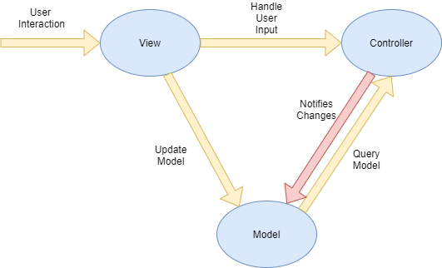

## 

## 

## **System and Subsystem Decomposition**

The system and subsystem decomposition is used to interpret how the application is structured. The application was made with React Native and deployed with Expo. The src folder contains all the components as well as the different languages employed. We had moved the Firebase.js file out of the components folder because we no longer considered it a component, but rather a form of class. We implemented React Hooks to replace class inheritance throughout the app. React Hooks use the logic behind class inheritance, but utilizes that logic with functions passing returns that are used whenever a component is called within another.

## **Deployment Diagram**

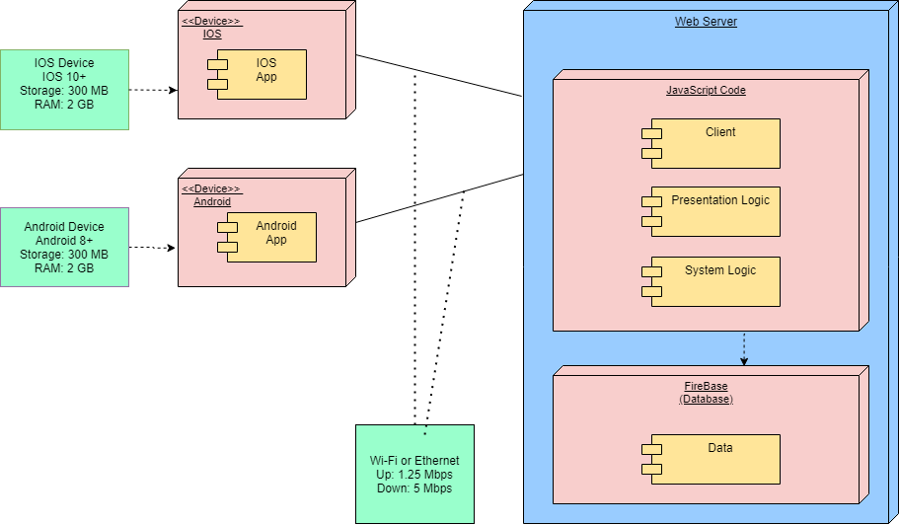

## 

## 

## 

## 

## **Design Patterns**

* Facade: The app uses a Facade design pattern to represent the UI in a user-friendly way without exposing the logic of the system to the user.
* Singleton: The app uses a Singleton design pattern to maintain only one instance of Firebase, with only one global access point to avoid instantiating the database API multiple times.
* Iterator: The app uses the Iterator design pattern to display multiple buttons, as well as display the Clinics and the Shelters.
* Chain of Responsibility: In the app several components delegate access of functions to other components which use a chain of responsibility design pattern.

**System Validation**

**Michael Llanes**

|  |  |
| --- | --- |
| **Case ID** | **Upload Documents** |
| **Purpose** | **Allows the user to upload documents regarding medical or financial information for themselves and the infant in question.** |
| **Preconditions** | **The user has documents that they want readily accessible within the application.** |
| **Expected results** | **The user will enter the ‘Documents’ tab within the ‘Resource’ page and be able to view or upload documents.** |

|  |  |
| --- | --- |
| **Case ID** | **Access Resource Page** |
| **Purpose** | **Provide the user with available government resources that may assist in the rearing of their infant.** |
| **Preconditions** | **The user is low-income and may want or need such resources.** |
| **Expected results** | **The user enters the application homepage, clicks on the ‘Resource’ tab and goes on to click links to WIC(Women, Infants, and Children) and Medicaid application websites.** |

# **Amin Sheikhnia**

|  |  |
| --- | --- |
| **Case ID** | **STD** |
| **Purpose** | **To add information about STDs.** |
| **Preconditions** | **The user desires the knowledge regarding STDs.** |
| **Expected results** | **The user is able to see information about STDs.** |

|  |  |
| --- | --- |
| **Case ID** | **Female Condom** |
| **Purpose** | **To add information about the female condom.** |
| **Preconditions** | **The user desires the knowledge regarding female condoms.** |
| **Expected results** | **The user is able to see information about the female condom.** |

**Noe Velasquez**

|  |  |
| --- | --- |
| **Case ID** | **Setting** |
| **Purpose** | **To update or make changes to the user information** |
| **Preconditions** | **Users must make any change to any fields provided by the setting section and click save.** |
| **Expected results** | **The user is able to update or change their personal information.** |

|  |  |
| --- | --- |
| **Case ID** | **Appointment** |
| **Purpose** | **Schedule Appointments** |
| **Preconditions** | **Users must provide the information for the appointments such as name of appointment, date, time, extra information.** |
| **Expected results** | **The user is able to schedule appointments for any medical purpose plus it will synchronize to the default calendar.** |

|  |  |
| --- | --- |
| **Case ID** | **Reference** |
| **Purpose** | **Reference your Doctor or any medical specialties** |
| **Preconditions** | **Users must provide the information of the reference such as name of reference, medical specialties, phone, email.** |
| **Expected results** | **The user is able to reference any medical specialties plus it allows them to make a call or email them.** |

**Gabriel Alfonso**

|  |  |
| --- | --- |
| **Case ID** | **Browse Facilities** |
| **Purpose** | **Allows the user to browse facilities like Clinics and Shelter to find an appropriate facility to visit.** |
| **Preconditions** | **The user has is logged in, has access to internet and is in the Clinics/Shelters Screen** |
| **Expected results** | **A list of Clinics or Shelters will be displayed for the user to browse and choose** |

|  |  |
| --- | --- |
| **Case ID** | **SMS Messages** |
| **Purpose** | **Provide the user with information, alerts, and reminders via SMS Messages** |
| **Preconditions** | **The user has provided a correct phone number, and meets the condition for the specific message** |
| **Expected results** | **The user receives a SMS Message to their phone within seconds** |

|  |  |
| --- | --- |
| **Case ID** | **Push Notifications** |
| **Purpose** | **Provide the user with push notifications for alerts and to maintain user engagement.** |
| **Preconditions** | **The user has allowed push notifications, and meets the qualifications for the notification to trigger** |
| **Expected results** | **The user receives a notification to their phone that links to the app.** |

# 

# 

# 

# **Glossary**

**Framework**: A basic structure underlying a system, concept, or text.

**Authentication**: The process of confirming if the user is who the user says it is

**Feature**: A capability that the software offers

**UI**: Short for User Interface. Is the display on which the user interacts

**Cloud functions**: Cloud Functions is a server less execution environment for building and connecting cloud services.

**API**: Short for Application Programming Interface. a set of functions and procedures allowing the creation of applications that access the features or data of an operating system, application, or other service.

**Twilio**: Twilio allows software developers to programmatically make and receive phone calls, send and receive text messages, and perform other communication functions using its web service APIs.

**Dependencies**: is a broad software engineering term used to refer when a piece of software relies on another one

**TestFlight**: is an online service for over-the-air installation and testing of mobile applications, currently owned by Apple Inc. and only offered to developers within the iOS Developer Program

**UML diagram**: Is a diagram based on the UML (Unified Modeling Language) with the purpose of visually representing a system along with its main actors, roles, actions, artifacts or classes, to better understand, alter, maintain, or document information about the system.

**PO**: Short for Product Owner. Is the person responsible for guiding changes and talk to developers about things that need to be modified on a software

**IDE**: Short for Integrated Development Environment. is a software application that provides comprehensive facilities to computer programmers for software development.

**Appendix**

## **Appendix A - UML Diagrams**

**Architecture Diagrams**



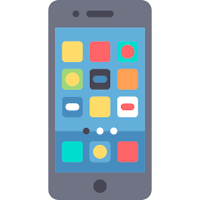  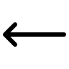

**Class Diagrams**

**Noe Velasquez**

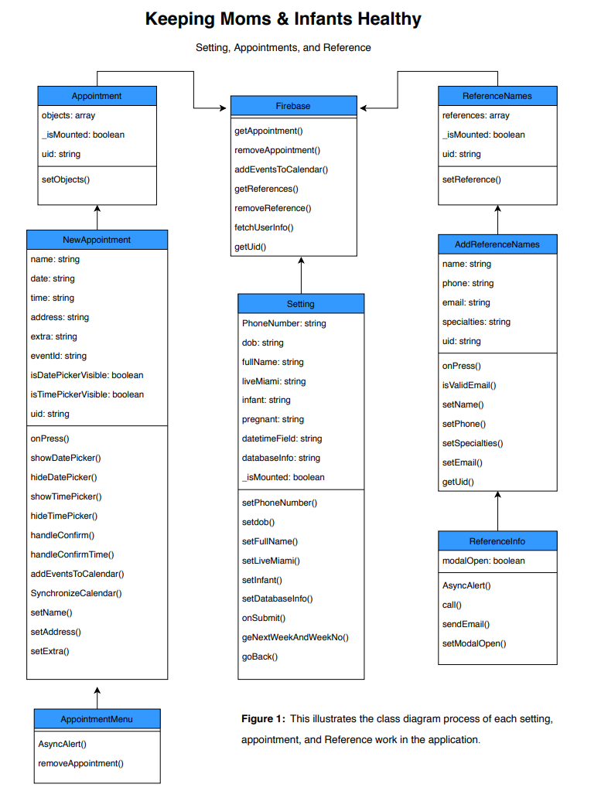

**Michael Llanes**

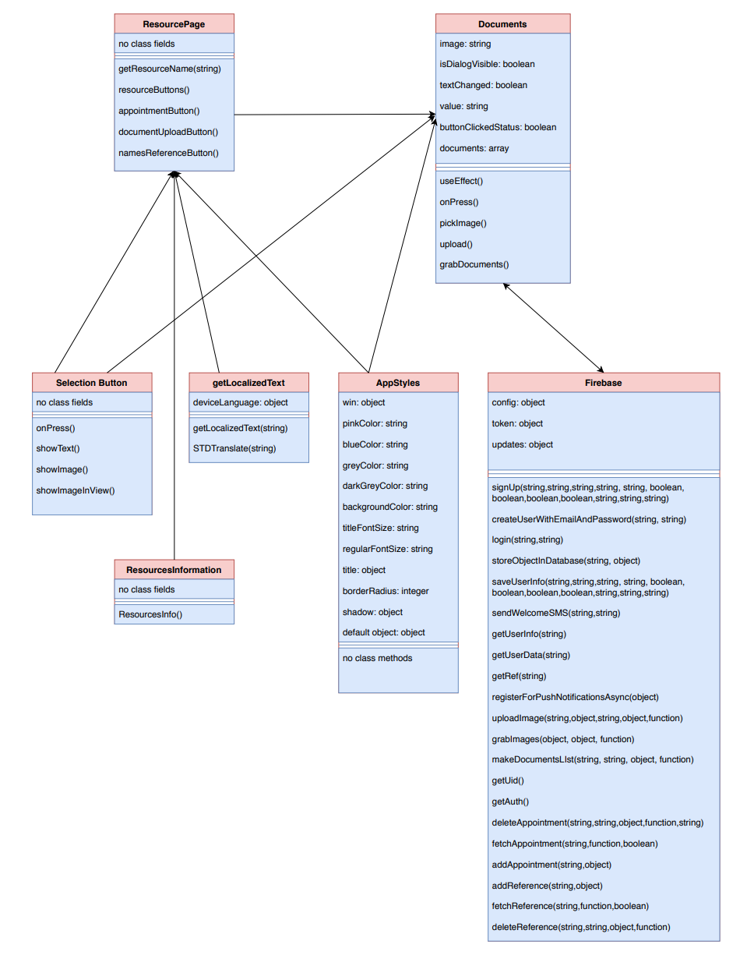

**Amin Sheikhnia**

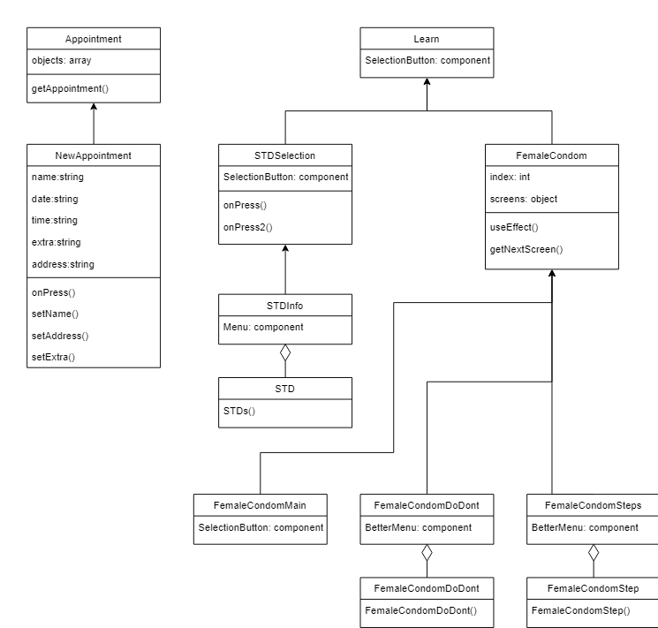

**Gabriel Alfonso**

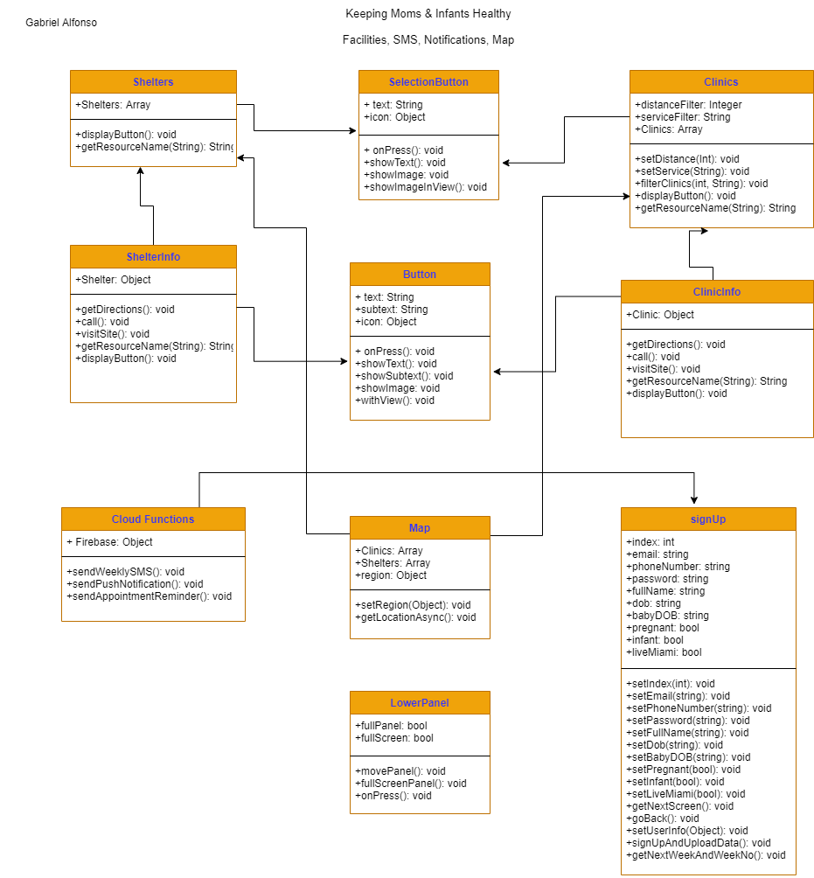

**Sequence Diagrams**

**Noe Velasquez**

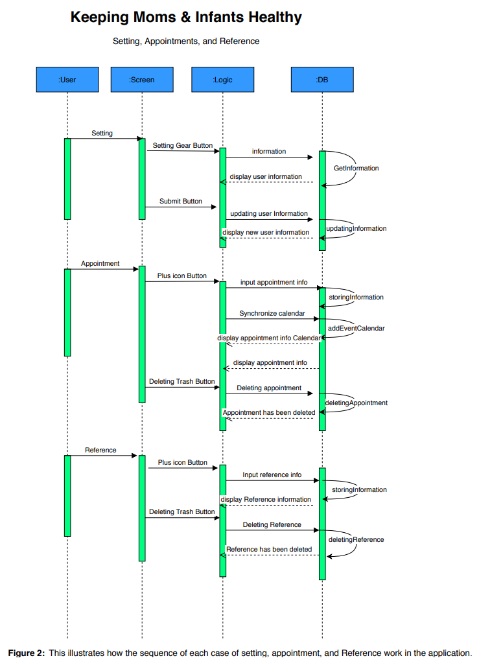

**Michael Llanes**

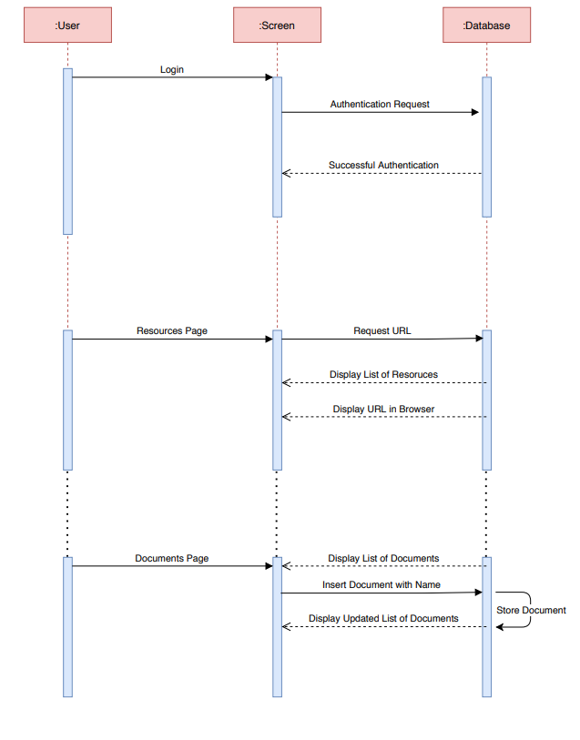

**Amin Sheikhnia**

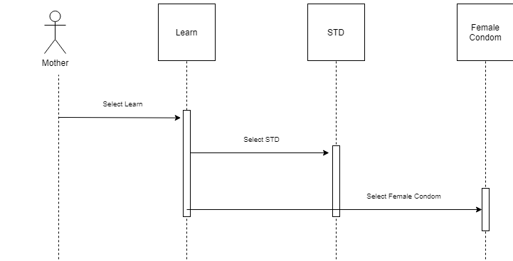

**Gabriel Alfonso**

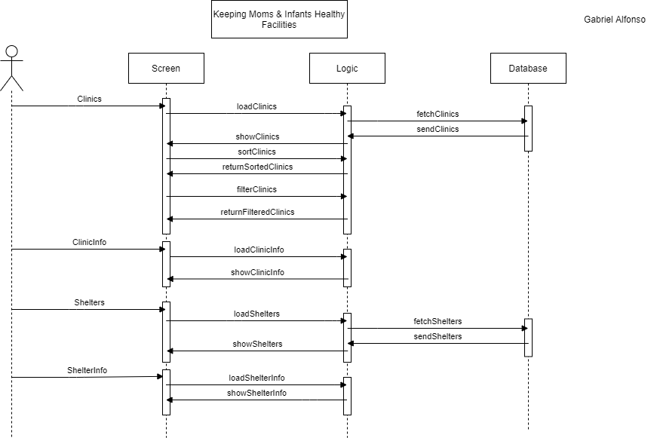

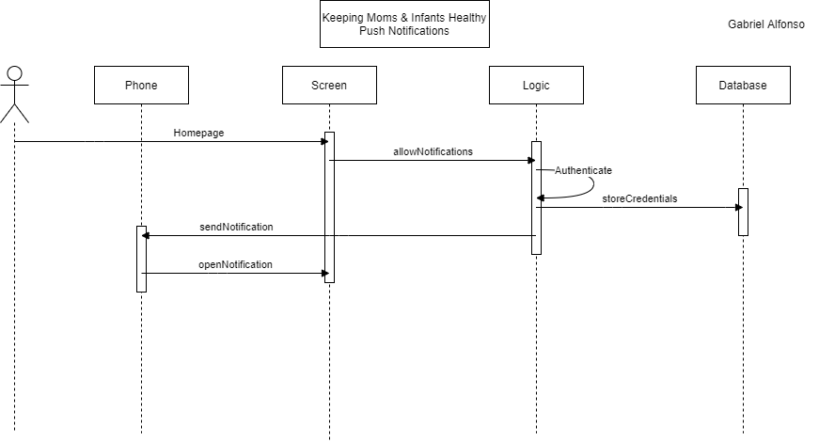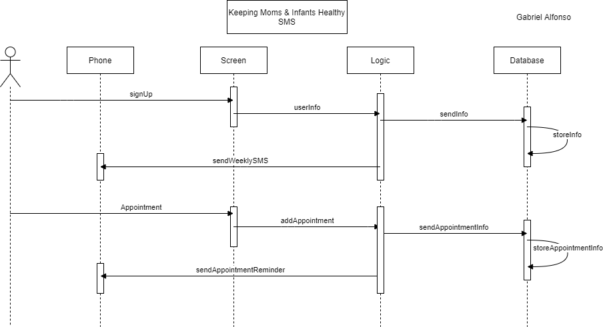

**Use-Case Diagrams**

**Noe Velasquez**

## **Michael Llanes**

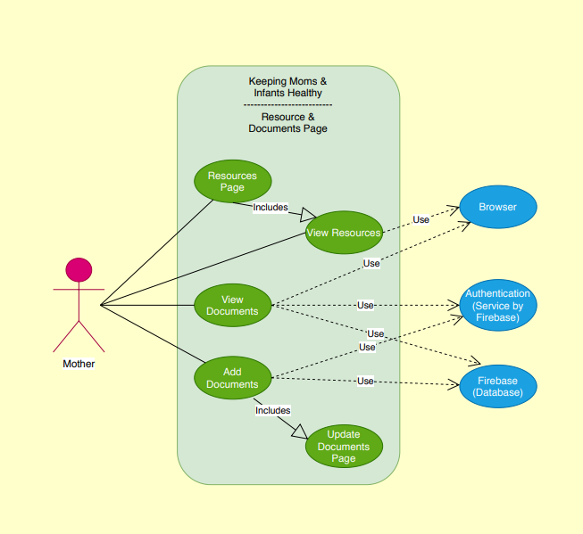

## **Amin Sheikhnia**

## 

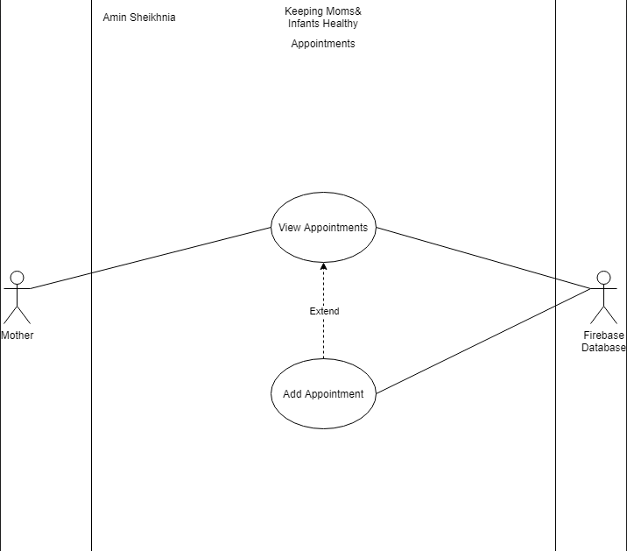

## 

## 

## 

## 

## 

## 

## **Gabriel Alfonso**

## 

## **o**

## 

## 

## 

## 

## 

## 

## **Appendix B - User Interface Design**

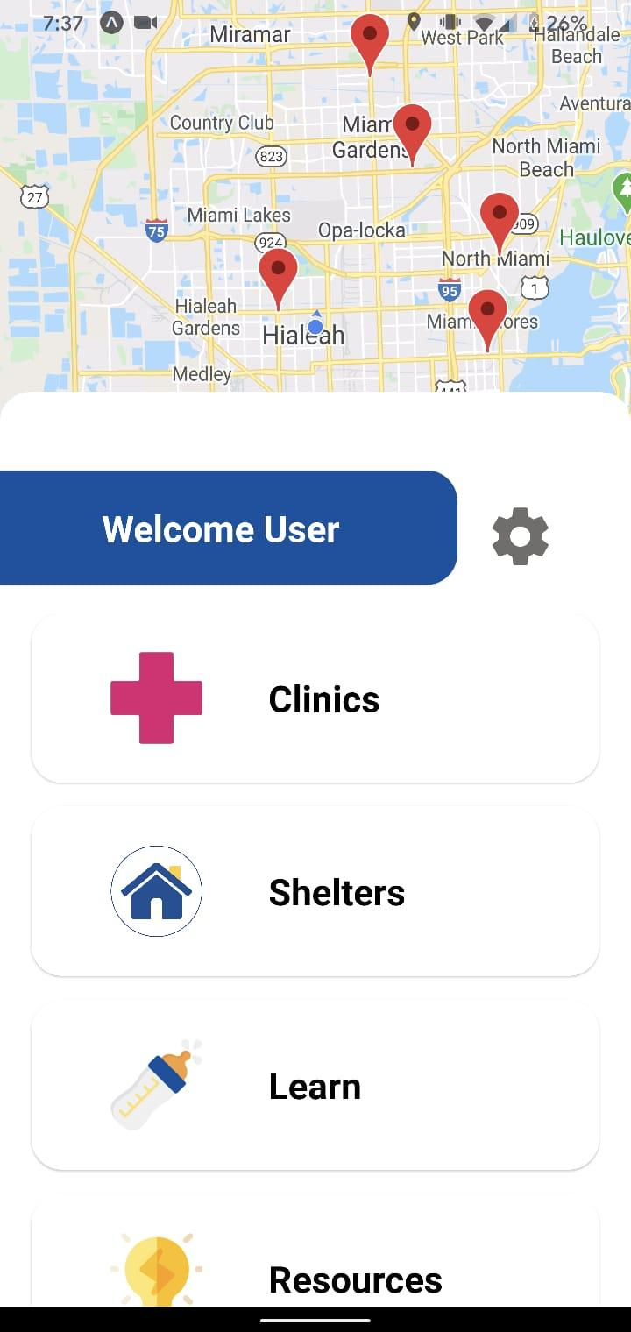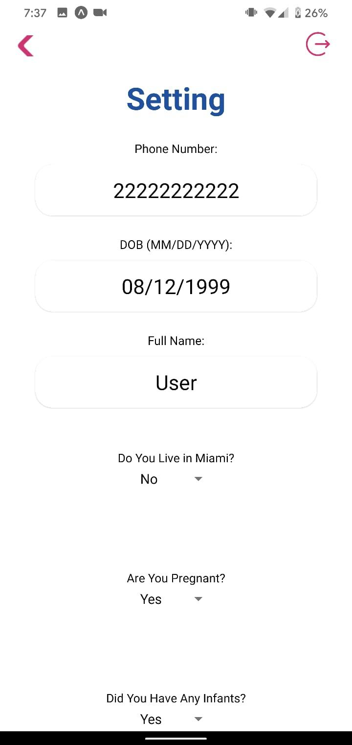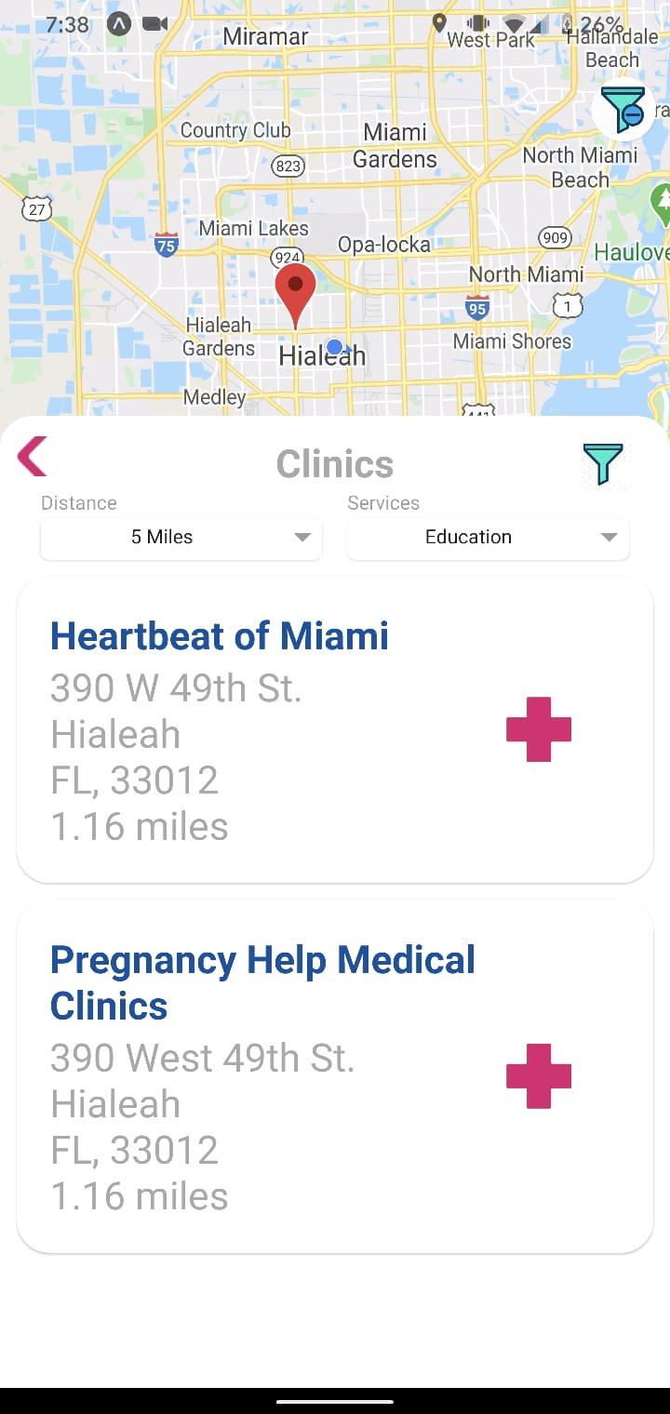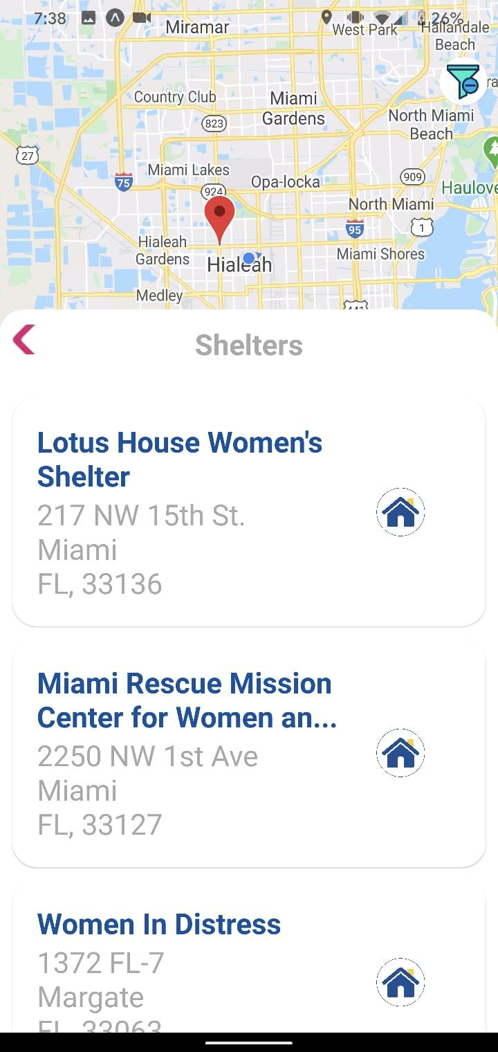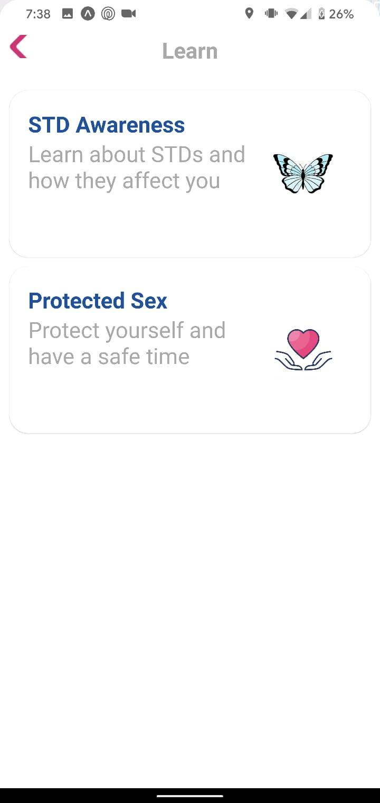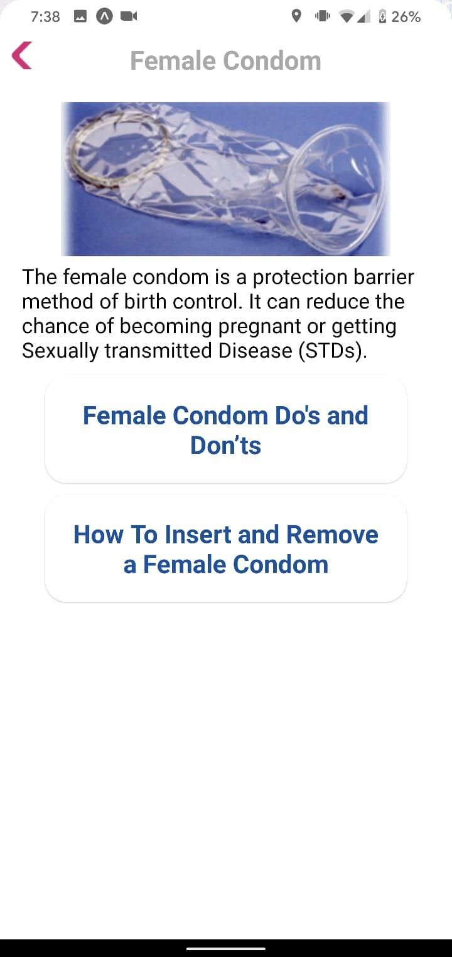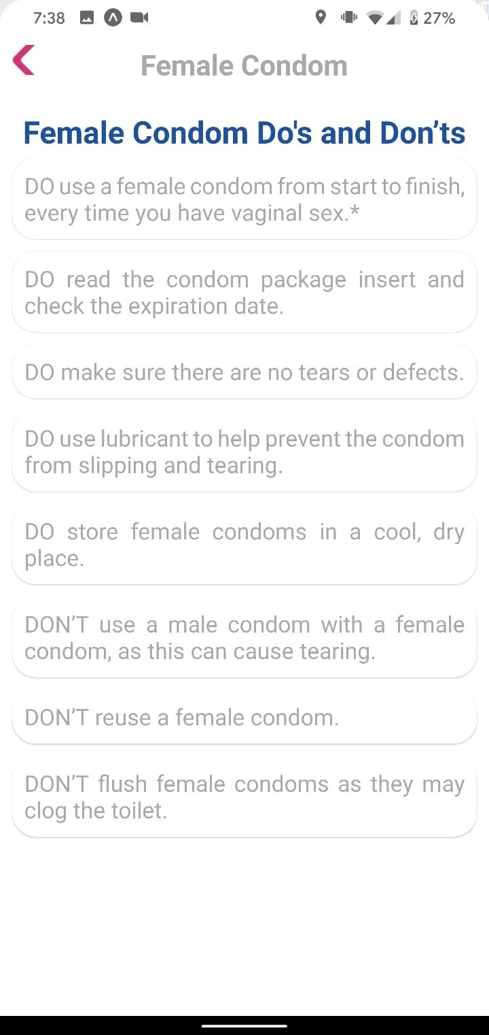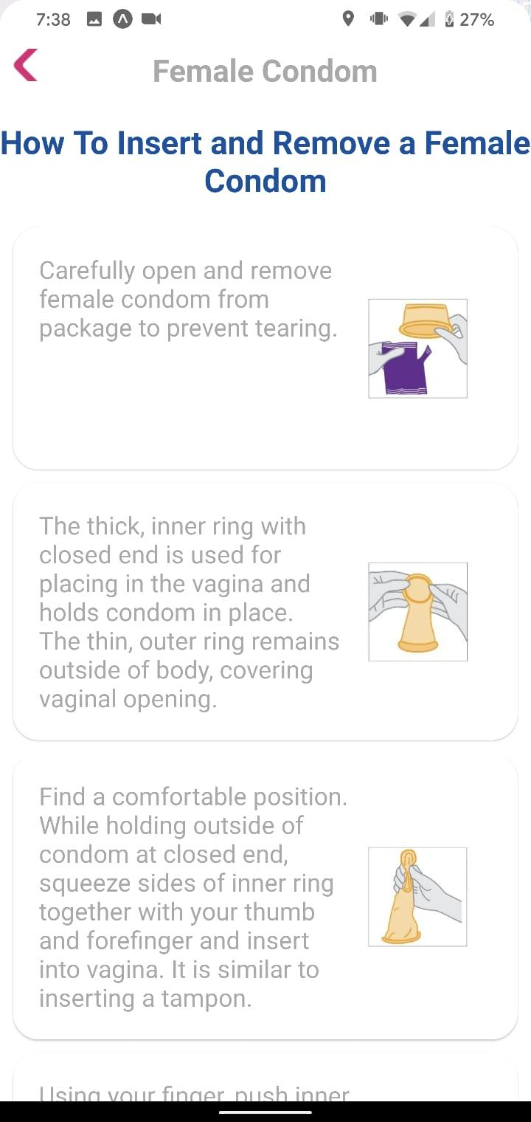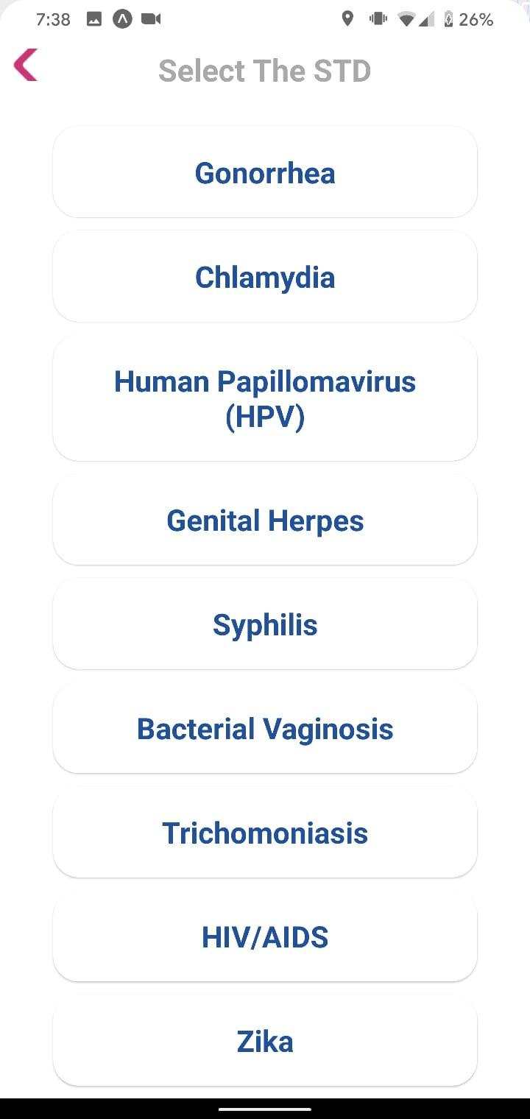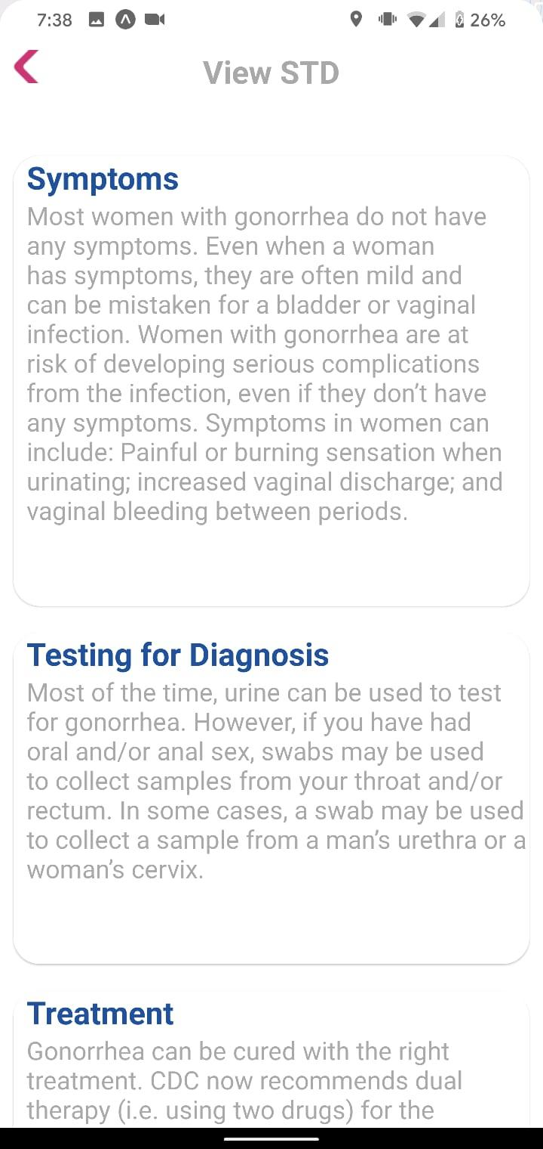

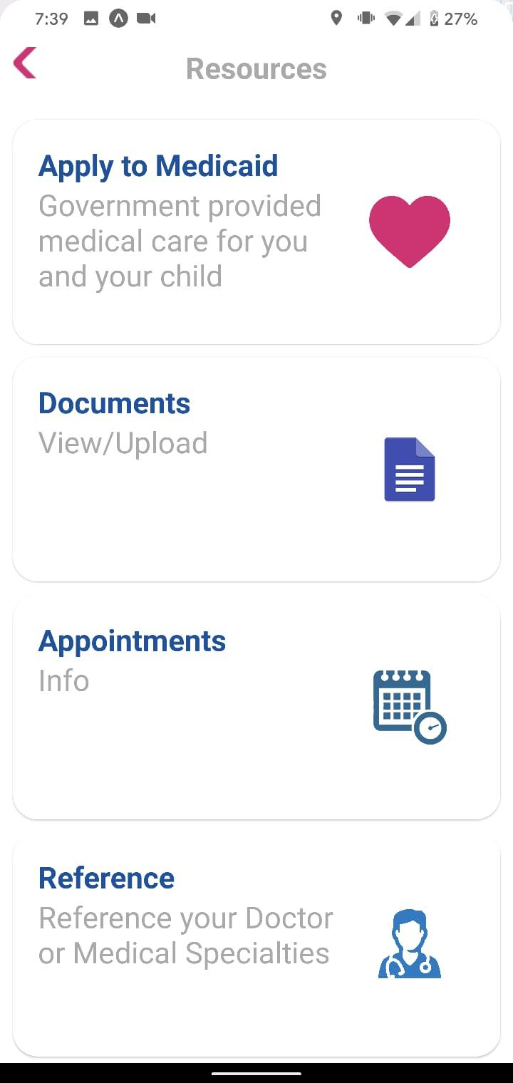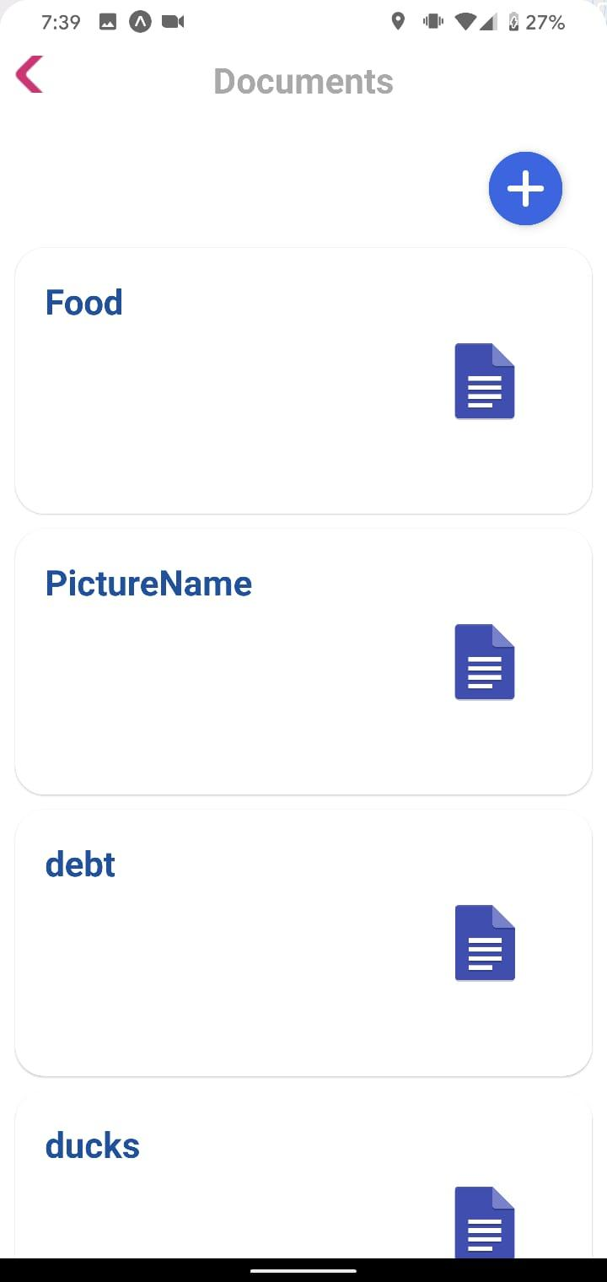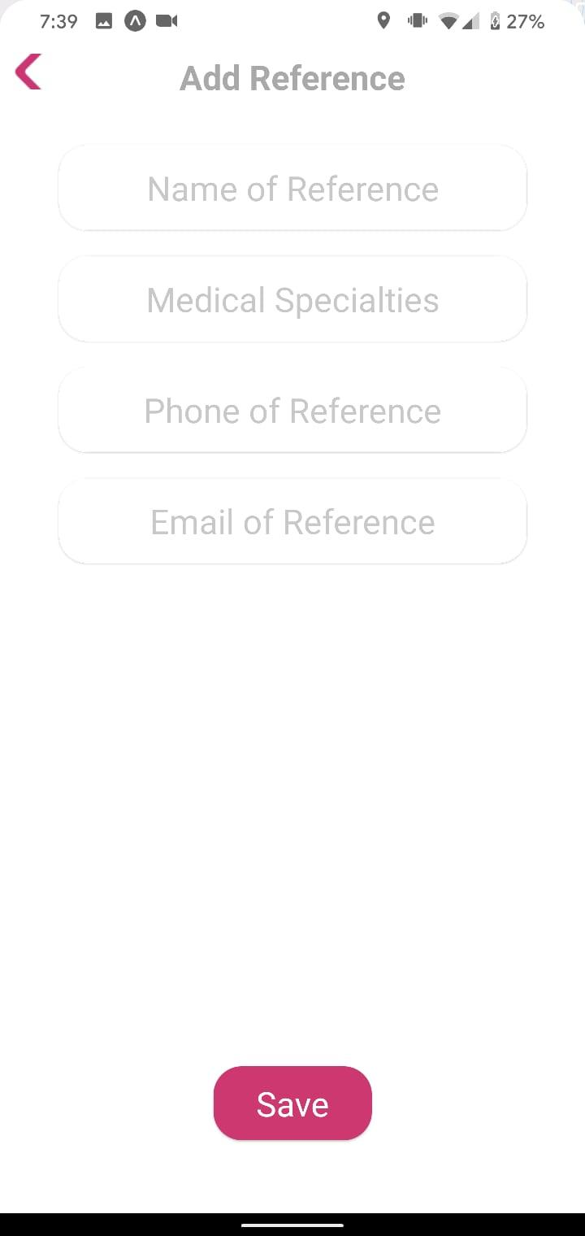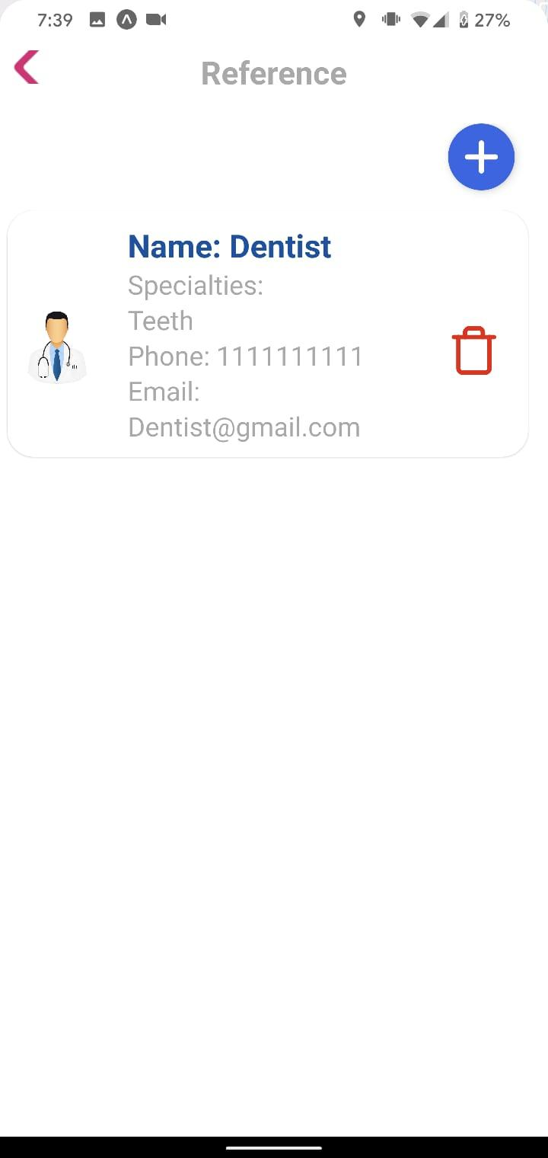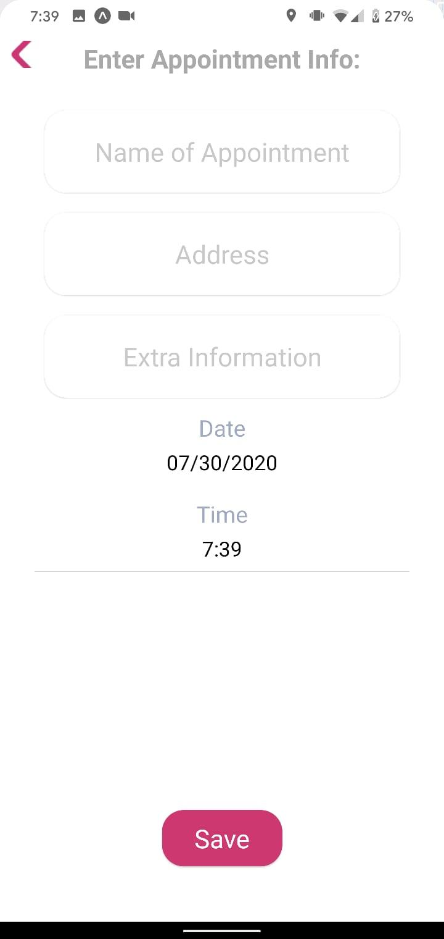

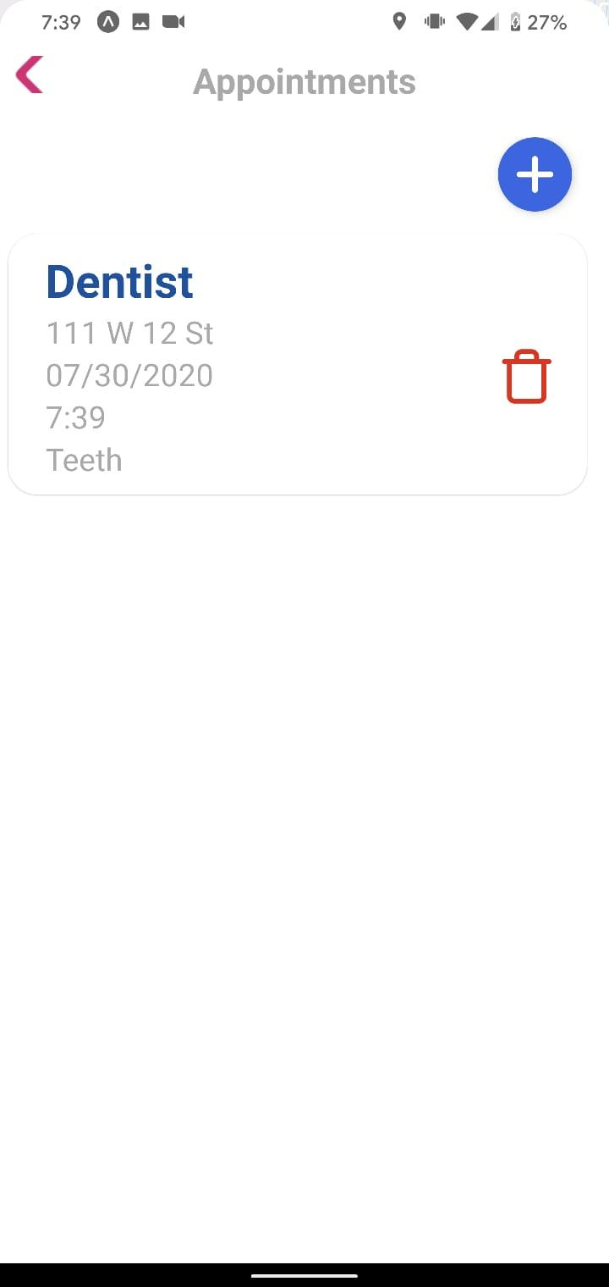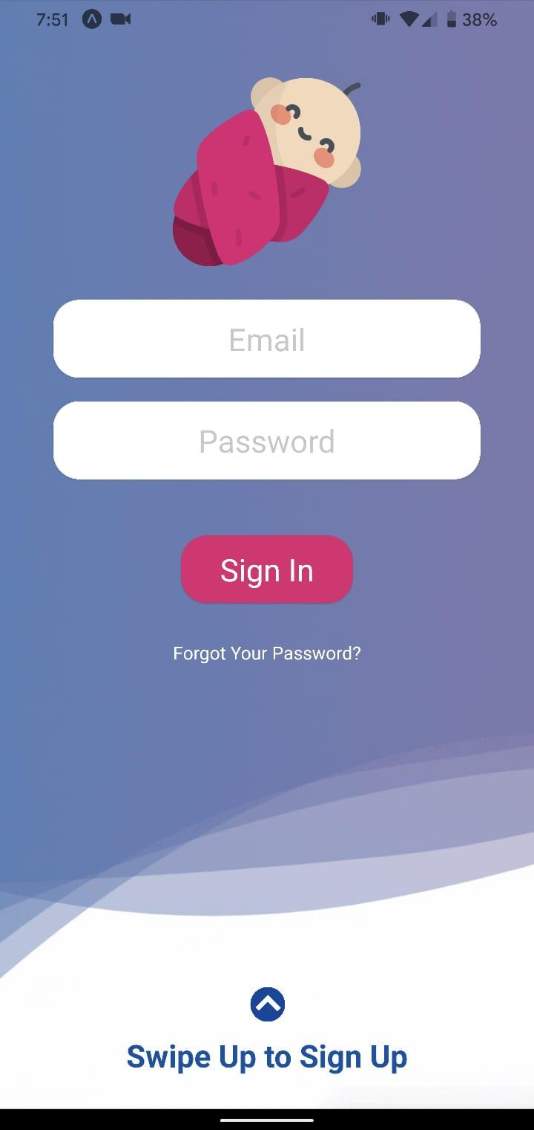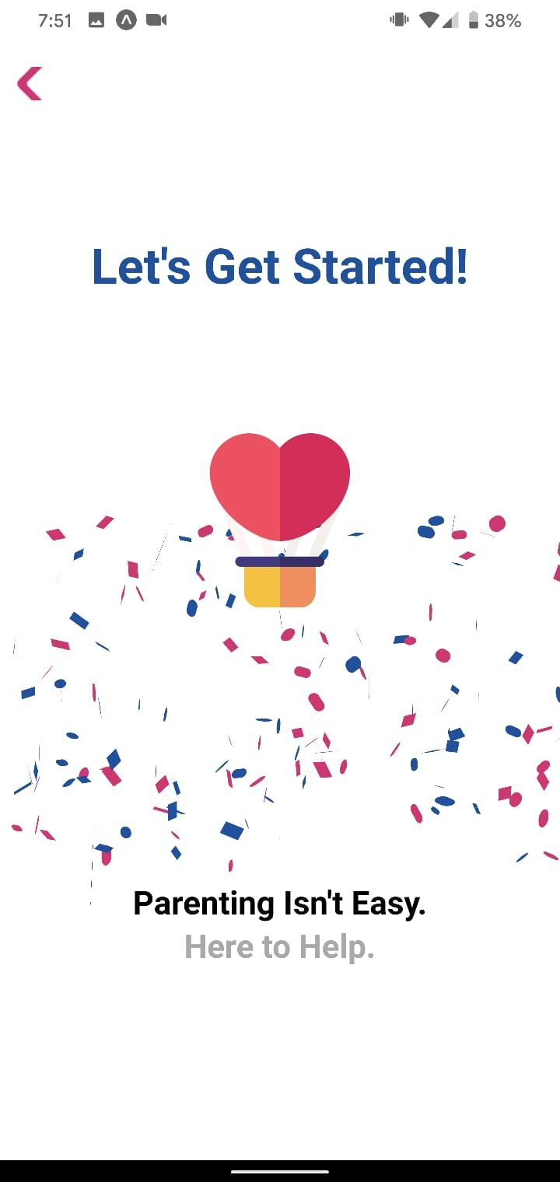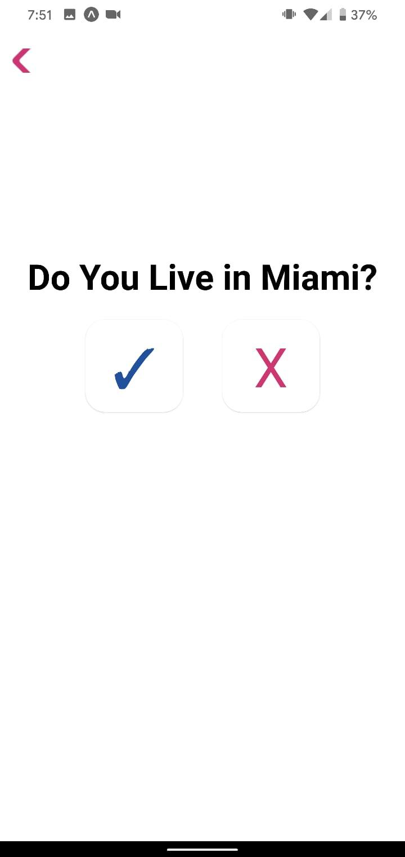

## **Appendix C - Sprint Review Reports**

Sprint 1

Summer 2020 Review 05/29/2020, 4PM-5PM

Michael Llanes, Noe Velasquez, Gabriel Alfonso, Amin Sheikhnia, Jean Hannan

● **List of Approved User Stories**:

User Story 1-5:

As a developer, I want to set up my development environment and learn the fundamentals of the technology stack we will use so that I can develop the required features.

User Story 6:

As a user I would like to have the application available to Android phones, so I can use the app.

User Story 7:

As a user I would like a back button on the lower panel so that I can go back to the selection.

User Story 8:

As a user I would like to focus the lower Panel by clicking its header so I can better navigate the app.

User Story 9:

As a user I would like the scroll functionality on all the lower panel sections so I can use it anywhere in the lower panel.

User Story 13:

As a user I would like to specify the age of my baby or whether they are born or not so I can better be served by the app.

User Story 14:

As a user I would like to add a setting edit icon where the user can edit info, logout or app setting so I can configure my user experience.

User Story 15:

As I user I would like to go back in between the sign up steps so I can make sure I provide accurate information

User Story 17:

As a user I would like input permanence in the sign up process, so I don’t have to re-enter information while signing up.

● **List of Rejected User Stories**:

User Story 10:

As a user I would like a weekly notification with tips about newborns so I can better take care of my baby.

User Story 11:

As a user I would like to access a learn tab which provides health information about pregnancy and birth so I can stay safe and keep my baby safe.

User Story 12:

As a user I would like to access a Tips & Tricks tab which provides useful information about tips and tricks of pregnancy, giving birth, child caring and sex safety so I can stay safe and healthy more productively.

User Story 16:

As a user I would like to see individual fields on entering my date of birth so that editing can be easier.

Sprint 2

Summer 2020 Review 06/13/2020, 2PM-3PM

Michael Llanes, Noe Velasquez, Gabriel Alfonso, Amin Sheikhnia, Jean Hannan

● **List of Approved User Stories**:

User Story 10:

As a user I would like a weekly notification with tips about newborns so I can better take care of my baby.

User Story 11:

As a user I would like to access a learn tab which provides health information about pregnancy and birth so I can stay safe and keep my baby safe

User Story 12:

As a user I would like to access a Tips & Tricks tab which provides useful information about Health Resources so I can better take advantage of the many resources available to me.

User Story 17:

As a nuMom(user), I would like to sort clinics by proximity, so I can better choose a convenient clinic to visit.

User Story 21:

As a user I would like to FILTER Clinics in terms of proximity (5 mile radius, 10 mile radius), so I can better choose a clinic that is right for me.

User Story 22:

As a user I would like to FILTER Clinics in terms of services they provide, so I can better choose a clinic that is right for me.

User Story 24:

As a user I would like to set up a forgot password feature , so users can reset the password based on the email.

User Story 25:

As a user I would like to stack the filters for clinics on top of each other to be able to filter multiple parameters at once.

User Story 27:

As a user I would like to have a button that when clicked resets all set filters to default, so I don’t have to manually reset them in the Clinics tab.

User Story 28:

As a developer, I would like a way to incorporate text fields for dates that are more intuitive and compatible in general, so that I can implement them in the app straightforwardly and with confidence.

● **List of Rejected User Stories**:

User Story 16:

As a user I would like to see individual fields on entering my date of birth so that editing can be easier.

User Story 18:

As a user I would like to upload and access certain medical documents with ease so that when they are requested or I must reference them for access to child-rearing care I can.

User Story 23:

As a user I would like to store appointments I have for my child and I so that I can easily keep track of my appointments.

User Story 26:

As a user I would like to get SMS notifications to notify me of my appointments so that I can be notified of my upcoming appointments.

Sprint 3

Summer 2020 Review 06/26/2020, 4:20PM-5PM

Michael Llanes, Noe Velasquez, Gabriel Alfonso, Amin Sheikhnia, Jean Hannan

● **List of Approved User Stories**:

User Story 23:

As a user I would like to store appointments I have for my child and I so that I can easily keep track of my appointments

User Story 26:

As a user I would like to get SMS notifications to notify me of my appointments so that I can be notified of my upcoming appointments.

User Story 29:

As a user I would like to receive in-app notifications so I can remember to use the app to its full potential

User Story 31:

As a user I would like to not disclose the gender of my baby if it is unnecessary, so I can provide less information and keep more of my privacy

User Story 33:

As an old user I would like the settings page to be compatible with my account, so I don't have to re-create my account

User Story 35:

As a developer I would like to transform the components to use functions and React hooks, so that the code is easier to read, to maintain, and to expand

User Story 36:

As a user I would like the delete filter button to only show up when there are filters to delete so that it doesn't get in the way when it is not needed.

User Story 37:

As a user I would like to delete appointments whenever I want, so that I can only see relevant appointments.

User Story 38:

As a user, I would like a button to show/hide the filter selection dropdown menus, so that I have more room to look at the clinics when hidden.

User Story 39:

As a user I would like to use the appointments tab efficiently and for it to look appealing to the eye so that I won't get frustrated when using the application.

User Story 41:

As a user I would like to edit the weekly messages json file, so that it has an efficient way to deliver messages.

User Story 42:

As a user I would like for appointments to delete themselves the day after the appointment occurred so they don't clutter up, and I don’t have to manually remove them.

User Story 43:

As a dev, I would like for the clinics to be stored in the database, so the App behaves more dynamically.

User Story 44:

As a user I would like the dropdown menu for the filters to look more aesthetically pleasing so my user experience is more fluid.

User Story 45:

As a user I would like to receive a push notification when I indicate that I have a new child, so that my user engagement with the app improves.

User Story 46:

As a user I would like a loading screen while the clinics are being fetched before the map is shown so that the map shows correct data when it does load.

User Story 47:

As a dev I would like for a new animation for the lowerPanel moving up and down, so that the app is more fluid and efficient.

User Story 48:

As a user I would like to take a picture within the app and save it immediately into the app and the phone.

User Story 50:

As a user I would like my images stored in a cloud so that I can access them on whichever device.

User Story 51:

As a user I would like to have those documents only accessible by me so that my information is secure.

● **List of Rejected User Stories**:

User Story 18:

As a user I would like to upload and access certain medical documents with ease so that when they are requested or I must reference them for access to child-rearing care I can.

User Story 30:

As a user I would like to get health alerts that would help keep me and my child safe.

User Story 32:

As a user I would like to add more Resources of Zika, WestNile, Dengue, Hepatitis information so I can inform the user with the health diseases.

User Story 34:

As a dev, I would like for Firebase to not create a new instance in every component, so the app can save memory and be more efficient.

User Story 40:

As a user I would like the clinics to load from a database, so that it loads the sorted clinics faster.

User Story 49:

As a user I would like to have all my saved files listed within the app so that I can access them conveniently.

Sprint 4

Summer 2020 Review 07/10/2020, 6PM-6:20PM

Michael Llanes, Noe Velasquez, Gabriel Alfonso, Amin Sheikhnia, Jean Hannan

● **List of Approved User Stories**:

User Story 18:

As a user I would like to upload and access certain medical documents with ease so that when they are requested or I must reference them for access to child-rearing care I can.

User Story 34:

As a dev, I would like for Firebase to not create a new instance in every component, so the app can save memory and be more efficient.

User Story 40:

As a user I would like the clinics to load from a database, so that it loads the sorted clinics faster.

User Story 49:

As a user I would like to have all my saved files listed within the app so that I can access them conveniently.

User Story 50:

As a user I would like to learn about female condoms, so I am better informed about sexual health.

User Story 53:

As a user I would like to view shelters that are useful and accessible so that I would have those options available to me.

User Story 56:

As a user I would like for the sign in page to not crash the app when I press the sign in button without offering any input, so that the app doesn't crash .

User Story 57:

As a user, I would like to sync the appointments from calendars to the app, so I don’t have to create it inside the app and have all the appointments in one place.

User Story 58:

As a dev I would like to import GetLocalizedText instead of passing it as props, so that the app is more efficient.

User Story 59:

As a user I would like to have a button in the upper right corner of the documents page that prompts for adding a document instead of it being in the center.

User Story 60:

As a developer I would like to abstract a Button component so that I can use it with all the buttons in the App instead of having several Button components, so that the code flows better.

User Story 61:

As a user I would like to change the New Appointment icon to a plus icon, so the app style looks decent and better.

User Story 62:

As a user I would like to change the Time and date to a Picker, so we could have better efficient data.

User Story 63:

As a user, I would like to be able to name the files I upload so that I can know what each document pertains to.

User Story 64:

As a user I would like to change the styles for Android Picker so the app looks decent.

User Story 65:

As a user I would like for the style of the picker for the dropdown filter to be improved so that it matches the rest of the app and improves my user experience

User Story 67:

As a dev, I would like to keep all the components inside LowerPanel inside an object of components, so that every component can be called by its property name.

User Story 51:

As a user I would like to store the name of my doctors and specialists in the app, so I can look at them for reference

● **List of Rejected User Stories**:

User Story 52:

As a developer, I would like to have the clinic services drawn from getLocalizedText so that it can be dynamic to the language the user is using.

User Story 54:

As a user I would like to have all information available in any language that I may want to read in so that I can properly utilize the application. (Waiting on PO for information).

User Story 55:

As a user I would like to have a link to a helpline that can provide me with further information so that I can be clear about my choices.

User Story 66:

As a user, I would like to upload other document types than just pictures in case I have a pdf or docx that I would like to keep track of through the application.

User Story 30:

As a user I would like to get health alerts that would help keep me and my child safe

User Story 32:

As a user I would like to add more Resources of Zika, WestNile, Dengue, Hepatitis information so I can inform the user with the health diseases.

Sprint 5

Summer 2020 Review 07/24/2020, 5PM-5:20PM

Michael Llanes, Noe Velasquez, Gabriel Alfonso, Amin Sheikhnia, Jean Hannan

● **List of Approved User Stories**:

User Story 32:

As a user I would like to add more Resources of Zika, Hepatitis information so I can inform the user with the health diseases.

User Story 54:

As a user I would like to have all information available in any language that I may want to read in so that I can properly utilize the application.

User Story 57:

As a user, I would like to sync the appointments from calendars to the app, so I don’t have to create it inside the app and have all the appointments in one place.

User Story 64:

As a user I would like to change the styles for Android Picker so the app looks decent.

User Story 68:

As a user I would like to see the STD names so that I can choose the STD I want to look at.

User Story 69:

As a user I would like for the lowerPanel to go full screen when on Learn and Resources so I can see better.

User Story 70:

As a user I would like for the app to recognize Creole as my language of preference and use it to translate the app to Creole.

User Story 71:

As a developer I would document the code so that later developers can use it to figure out what is there.

User Story 72:

As a user I would like for the lowerPanel to be taller in the Selection so that I can see all the tabs.

User Story 73:

As a user I would like to make decent styles on Android so users with Android phones can use the app.

User Story 74:

As a developer I would like to fix the Gear icon for the phone, so it looks decent on the phones.

User Story 75:

As a user I would like to see all the tabs from the Selection Lower Panel without having to scroll so that I am aware of all the tabs that the App offers.

User Story 76:

As a user, I want the documents page to reload when I upload a new file so that I can view documents as I upload them.

User Story 77:

As a user, I want the documents page to have my full list of documents when I first open it.

● **List of Rejected User Stories**:

User Story 30:

As a user I would like to get health alerts that would help keep me and my child safe.

User Story 55:

As a user I would like to have a link to a helpline that can provide me with further information so that I can be clear about my choices.

Sprint 6

Summer 2020 Review 07/24/2020, 4:25PM-5:20PM

Michael Llanes, Noe Velasquez, Gabriel Alfonso, Amin Sheikhnia, Jean Hannan

● **List of Approved User Stories**:

User Story 78:

As a developer, I want to complete a compilation of videos that summarize how to work in the application, what work the team completed throughout our development process and how to properly utilize it, and what needs to be done next so that future developers and colleagues may understand our work.

User Story 79:

As a developer, I want to complete a poster that summarizes the work we completed so that our colleagues may understand our work.

User Story 80:

As a developer, I want to complete a lengthy document that summarizes the work we completed so that our colleagues may understand our work.

User Story 81:

As a developer, I want to complete a set of presentation slides that summarizes the work we completed so that our colleagues may understand our work.

User Story 82:

As a developer, I want to complete the code and its README.md so that our colleagues may understand our work.

● **List of Rejected User Stories**:

None

**Appendix D - User Manuals, Installation/Maintenance Document, Shortcomings/Wishlist Document and other documents**

**User Manual**

The user may sign up or login in the initiation of the application. There is also a forgot your password button that allows the user to reset their password via email. Throughout the signup process they must provide any information prompted for to properly use the application as well as any account information necessary for account creation. In the home page they will see six things; a map with available clinics, a cog for the settings page, a ‘Clinics’ tab, a ‘Shelters’ tab, a ‘Learn’ tab, and a ‘Resources’ tab. Upon pressing the cog the user will see fields that are all the information relevant to their account. They may edit these at will and save the changes at the bottom of the page. In this page there is also a logout button on the upper right hand corner. In the ‘Clinics’ tab the user will be able to see a list of clinics sorted by closest proximity to them and a filtering button on the upper right hand corner. Upon pressing a clinic the user will have access to extensive information regarding it. Upon pressing the filtering button the user will see two filters pop up at the top: distance and services. These filters are drop down menus that allow the user to filter the clinics they see in the list and the map according to whichever services or distances they would like. In the ‘Shelters’ tab the user may enter it and view a list of shelters for women and mothers available in Miami. In the ‘Learn’ tab the user will see two more tabs: ‘STD Awareness’ and ‘Protected Sex.’ Upon pressing the ‘STD Awareness’ tab the user will see a list of buttons named with a variety of STDs. In clicking those tabs the user will view information regarding the disease they chose including symptoms, testing information, treatment information, consequences, and information about when it is OK to continue sexual activity. In the ‘Protected Sex’ tab the user will view information regarding the use of female condoms. Two other tabs exist in this page: ‘Female Condoms Dos and Don’ts’ and ‘How to Insert and Remove a Female condom.’ Upon pressing those tabs, the user will see the information relevant to their topics.

Once the user clicks on the resources tab they will see two tabs regarding applications to Medicaid and WIC. Upon clicking on either of these tabs they will be linked to websites for the relevant government program’s application. Upon entering the documents tab in the resources page the user will see a plus button that allows them to upload an image from their phone’s gallery. Upon choosing the image the user will be able to crop the image, select OK, then will be prompted with an input box that allows the user to name the file. These files will be immediately stored in the cloud via Firebase and the user will be able to view them in the documents page. Also in the ‘Resources’ tab is the appointments page. Upon clicking this tab, the user will see another plus button that will allow them to enter information regarding an appointment. Once that information is entered it will be stored in Firebase and immediately ready for view in the appointments page. The user will then be prompted to allow access to their phone’s calendar application in order to sync the recently made appointment to it. There is also a trash bin button on the tabs for every appointment that allows the user to delete the appointment. Also in the resources tab is the references page. Upon clicking this tab, the user will see another plus button that will allow them to enter information regarding a medical or financial reference. Once that information is entered it will be stored in Firebase and immediately ready for view in the references page. There is also a trash bin button on the tabs for every reference that allows the user to delete the reference.

**Installation/Maintenance**

* Install git on your computer
* On the command line interface check if git is installed by running the command git --version if the CLI returns a version number then it is installed. In case git is not installed the CLI will prompt you to install it
* Install npm
* First install homebrew by running the command the command /bin/bash -c “$(curl -fsSL <https://raw.githubusercontent.com/Homebrew/install/master/install.sh>)”
* After brew is installed, run the command: “brew update” to update brew with a list of the latest version of node
* Finally, type “brew install node”

**Step 1**:

Download Visual Studios Code from your browser through:

<https://code.visualstudio.com/download>

**Step 2**:

Open Visual Studios Code and select get from version control, from the dropdown, select git. A link will be requested where you will input the following link: <https://github.com/edumorlom/moms-infants-healthy.git>

**Step 3**:

After the project is cloned in your computer you will be able to access it from your command line interface. After that, go to your project from the terminal by using “cd” and going to the folder where the project is in.

**Step 4**:

Install all the backend node dependencies by running the command “npm install” in the root directory.

**Step 4**:

Install all the backend node dependencies by running the command “npm install” in the /functions directory.

**Step 5**:

After the previous step is done you will need to install “expo” to run the project. To do this, use the command “npm install expo-cli –global”

**Step 6**:

Install expo client on your phone

Google Play Apple App Store

**Step 7**:

Once everything is completed, use the command within the root folder “expo start” or “npm start” to start expo. A window will open in your default browser with a QR code to be scanned with your phone. The application now will show up in your phone on the application of the expo client.

**Wishlist**

**Document Deleting, Renaming, & Broadened Access**

The user should be able to delete documents in the documents page. They should be able to rename documents as they like. They should also be able to upload other types of documents besides pictures as currently only images may be uploaded.

**Help-Line**

The user should be able to get a help line number link that opens their phone app with the number provided by the application.

**Health Alerts**

The user should be able to view a health alerts tab provided in the homepage that gives the user relevant information to health-crises going on in the area or the world.

**Guest Access**

A user should be able to access the application without having to make an account.

**Translations**

Translations should be made for every single component in the phrases file for the English language to Creole and Spanish.

**Messaging Service**

The user should be able to chat with other moms online and a help line provided by the institution in charge of the application.

**Expanded Servicing**

Currently the application only provides information on clinics in the state of Florida, though this application should be available for use throughout the whole world.

**Weekly SMS Messages in Database**

Make the weekly text messages a json file in the Firebase database that the application pulls from so that it does not rely on the server hosting the app to function. It is currently in the code folder for the software.

**References**

[1] Firebase Documentation. (n.d). retrieved June 15, 2020, from: <https://firebase.google.com/docs>

[2] JavaScript documentation. (n.d). retrieved June 15, 2020, from: <https://devdocs.io/javascript/>

[3] Twilio. (n.d). retrieved June 15, 2020, from: <https://www.twilio.com/docs>

[4] CDC. (n.d). retrieved June 15, 2020, from: <https://www.cdc.gov/>

[5] React Native Documentation. (n.d). retrieved June 15, 2020, from: <https://facebook.github.io/react-native/docs/getting-started>

[6] Expo Documentation. (n.d). retrieved June 15, 2020, from: <https://docs.expo.io/versions/latest/>

[7] Git documentation. (n.d). retrieved June 15, 2020, from: <https://git-scm.com/doc>